Post Details |  | Last Updated: October 2025
Faculty/Administrative/Service Department | Research, Innovation and Impact (RII)
Job Title | Technology Transfer Manager
Job Family | Professional Services |  | Job Level | Level 5
Responsible to | Managing Director, Innovate Surrey Ltd
Responsible for (Staff) | N/A
Job Purpose Statement

The Technology Transfer Manager will play a key role within Innovate Surrey Ltd (ISL) to support the delivery of the University’s Vision 2041 - to be recognised internationally as a hub for game-changing innovation. ISL’s mission is to deliver this goal by supporting the effective translation and commercialisation of university research into impactful technologies and commercial solutions that address key societal challenges.
Working within the ISL team, the postholder will lead the identification, protection, management and commercialisation of the University’s intellectual property with an emphasis on maximising licensing and spinout opportunities. The postholder will engage proactively with researchers, external partners and funders to identify high-potential propositions, develop commercial opportunities and drive commercialisation through the negotiation of licensing agreements and the formation and follow-on support of spinout companies.
The postholder will work closely with a wider network of specialist innovation and engagement support teams across the University, both based centrally in RII and embedded within Faculties and the Pan-University Institutes. This is a senior position within the ISL team and the postholder will have the opportunity to take a leading role in the development of ISL and delivering impact at scale through fostering a spirit of innovation and entrepreneurship across the University.
Key Responsibilities This document is not designed to be a list of all tasks undertaken but an outline record of the main responsibilities (5 to 8 maximum)
- Lead operational leadership in the identification, protection, management and commercialisation of intellectual property (IP) developed across the University
- Oversee the identification of new IP generated through research and undertake prior art, technical and market evaluations to inform decisions on IP protection
- Manage a portfolio of technology transfer projects at different stages in their lifecycle, supporting and directing routes to commercialisation through licensing or spinout activity in collaboration with the Managing Director (MD) of ISL
- Lead with external legal and patent professionals to manage IP protection and management including assignments, patent filings and prosecutions and maintain knowledge on best practice in IP management
- Oversee the development of detailed commercialisation plans for technology transfer projects, working closely with the principal investigators and supporting applications for translational funding
- In collaboration with the MD of ISL, lead the negotiation, drafting and completion of licence agreements
- Oversee the development of spinout business plans and, in collaboration with the MD of ISL, negotiate and draft spinout formation agreements
- Develop and maintain strategic relationships with regional and national partners. Keep up to date with external funding, priorities and best practice relating to research impact and routes to achieving impact, ensuring internal strategy is updated appropriately.
- Lead the University in forums and boards as required, deliver presentations, and promote the expertise, know-how and technology that the University can provide.
N.B. The above list is not exhaustive.

All staff are expected to:
- Positively support equality of opportunity and equity of treatment to colleagues and students in accordance with the University of Surrey Equal Opportunities Policy.
- Work to achieve the aims of our Environmental Policy and promote awareness to colleagues and students.
- Follow University/departmental policies and working practices in ensuring that no breaches of information security result from their actions.
- Ensure they are aware of and abide by all relevant University Regulations and Policies relevant to the role.
- Undertake such other duties within the scope of the post as may be requested by your Manager.
- Work supportively with colleagues, operating in a collegiate manner at all times.

Help maintain a safe working environment by:
- Attending training in Health and Safety requirements as necessary, both on appointment and as changes in duties and techniques demand.
- Following local codes of safe working practices and the University of Surrey Health and Safety Policy.
Elements of the Role
This section outlines some of the key elements of the role, which allow this role to be evaluated within the University’s structure. It provides an overview of what is expected from the post holder in the day-to-day operation of the role.
Planning and Organising
- Success in this role is reliant on building strong, successful relationships both internally, with research staff, nurturing an awareness of the benefits of commercialisation and impact across the University, and externally, building and maintaining an extensive external network of contacts.
- The postholder is expected to keep up to date with the research activities of staff and to identify a pipeline of high-potential propositions arising from the research outputs. They are required to quickly assimilate the key technical, commercial and societal advantages of any new technology, utilise a network of contacts to assess the value and potential for exploitation to deliver income and impact, and to assist academic staff in obtaining translational funding to further the project.
- For technologies identified as having possible significant commercial (or non-commercial) impact, the postholder will assess the opportunity, ensure the IP is identified and where necessary protected, and plan and support the route to commercialisation. The postholder will draft and negotiate heads of terms with counter-parties within a remit agreed with the MD of ISL and then move to drafting and completing the agreements. The postholder may be involved in engaging and managing consultants and carrying out or commissioning market research.

Problem Solving and Decision Making.
- Good analytical, problem solving and decision-making skills, and sound political judgement are essential to the role as university policies and procedures may not cover all issues that arise in a portfolio of commercialisation projects. With the support of the MD of ISL, the postholder is expected to resolve problems or issues by identifying key components and applying their extensive knowledge and experience to generate solutions which produce acceptable and timely outcomes.
- The ideal candidate will be a confident, effective and empathetic communicator who can work closely with academic inventors to present technologies and solutions effectively to investors, customers and partners in order to develop the maximum impact and hence return for the inventors and the University.

Continuous Improvement
- The postholder will be required to maintain an up to date understanding of developments in science, technologies, createch, innovation and markets relevant to the University’s key research and innovation areas. They will be required to support academics in identifying high-potential propositions and sources of translational funding as well as the subsequent development of commercial opportunities
- The postholder will continuously review and improve the technology transfer and commercialisation processes and procedures, working with the ISL team and key university stakeholders to ensure processes are effective, allocate resources efficiently and deliver a pipeline of high-value commercial opportunities.

Accountability

- The postholder will work with a high degree of autonomy and therefore, carries a high level of accountability for the quality and professionalism of the services provided. Working with the MD of ISL, the postholder is expected to consider a range of options and present the best options and solutions to deliver technology transfer projects with potential for significant income.

Dimensions of the role
- Although it is essential that the postholder has significant technical and market knowledge related to their aligned discipline or innovation specialism, they will also be required to assume responsibilities for other technologies outside their specialty remit from time to time. In addition, business and commercial acumen, marketing and good interpersonal skills are important to be successful in the role.
Supplementary Information
As the structure of ISL evolves, the post holder may be required to manage junior technology transfer staff and to ensure that any consultants engaged fulfil their contractual obligations.
Person Specification This section describes the sum total of knowledge, experience & competence required by the post holder that is necessary for standard acceptable performance in carrying out this role.
Professionally qualified with a relevant postgraduate qualification, plus broad management experience in a similar or related role  Or  Substantial vocational and relevant management experience, demonstrating management ability in an appropriate professional or specialist area, and success in similar or related roles, supported by evidence of significant appropriate knowledge. |  |  |  |  | E
Member of a wide network of professional interest groups |  |  |  |  | E
Post-graduate qualification in a relevant subject (ie science, engineering, createch or other innovation-facing discipline) |  |  |  |  | E
Technical Competencies (Experience and Knowledge) This section contains the level of competency required to carry out the role (please refer to the Competency Framework for clarification where needed and the Job Matching Guidance). |  |  |  | Essential/  Desirable | Level  1-3
Project management skills and proven ability to manage multiple concurrent projects and to work effectively in diverse teams |  |  |  | E | 3
Strong interpersonal and influencing skills with the ability to work collaboratively across internal and external stakeholders |  |  |  | E | 3
Experience of developing business plans and financial forecasts for spinouts and startups |  |  |  | E | 3
Experience of developing multi-year translation and commercialisation plans for complex technologies |  |  |  | E | 3
Demonstrable experience of continuous improvement of commercialisation processes and systems |  |  |  | E | 3
Experience of negotiating complex commercial and legal agreements |  |  |  | E | 3
Experience of IP protection, patenting and IP management |  |  |  | E | 3
Commercial awareness and the ability to undertake detailed IP and market evaluations in technology-based industries |  |  |  | E | 3
Previous experience in technology transfer within a research or commercial environment |  |  |  | E | 3
Special Requirements: |  |  |  |  | Essential/  Desirable
Must be prepared to travel and work outside normal hours when required |  |  |  |  | E
Core Competencies This section contains the level of competency required to carry out this role. (Please refer to the competency framework for clarification where needed). n/a (not applicable) should be placed, where the competency is not a requirement of the grade. |  |  |  |  | Level  1-3
Communication  Adaptability / Flexibility  Customer/Client service and support  Planning and Organising  Continuous Improvement  Problem Solving and Decision-Making Skills  Managing and Developing Performance  Creative and Analytical Thinking  Influencing, Persuasion and Negotiation Skills  Strategic Thinking & Leadership |  |  |  |  | 3  3  3  3  3  3  n/a  3  3  2
This Job Purpose reflects the core activities of the post. As ISL and the post holder develop, there will inevitably be some changes to the duties for which the post is responsible, and possibly to the emphasis of the post itself. The University expects that the post holder will recognise this and will adopt a flexible approach to work. This could include undertaking relevant training where necessary.

Should significant changes to the Job Purpose become necessary, the post holder will be consulted and the changes reflected in a revised Job Purpose.
Organisational/Departmental Information & Key Relationships

Background Information

ISL is part of R&I and focuses on delivering impact at scale from the translation and commercialisation of University research outputs.

Department Structure Chart

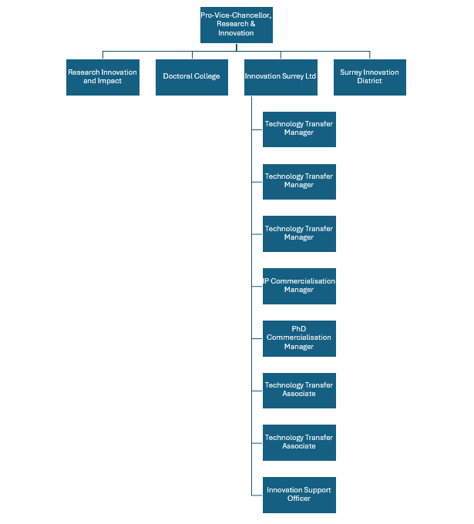

Relationships
Contacts include:
Internal
- ISL team
- Researchers
- Associate Dean (Research and Innovation) and Heads of Schools in Faculty
- Research and Innovation Office colleagues
- Research Innovation and Impact colleagues
- Surrey Innovation District colleagues
- Innovation & Impact Accelerator Managers
- Faculty Impact Champions
- Faculty Research and Innovation managers
External
- Businesses
- UKRI including EPSRC, STFC, Innovate UK and other Government funding bodies
- Knowledge Transfer Network and Catapults
- Other External funders
- IP Group
- USSF
- Senior managers in HEIF partner Universities
- SETsquared personnel
- Board members of external industrial and commercial partners
- University spin-out companies
- Patent Attorneys
- Consultants
- Market researchers

